**ABC COMPANY DATA ANALYSIS**

import pandas as pd

import numpy as np

df = pd.read_csv('ABC_company.csv')

df

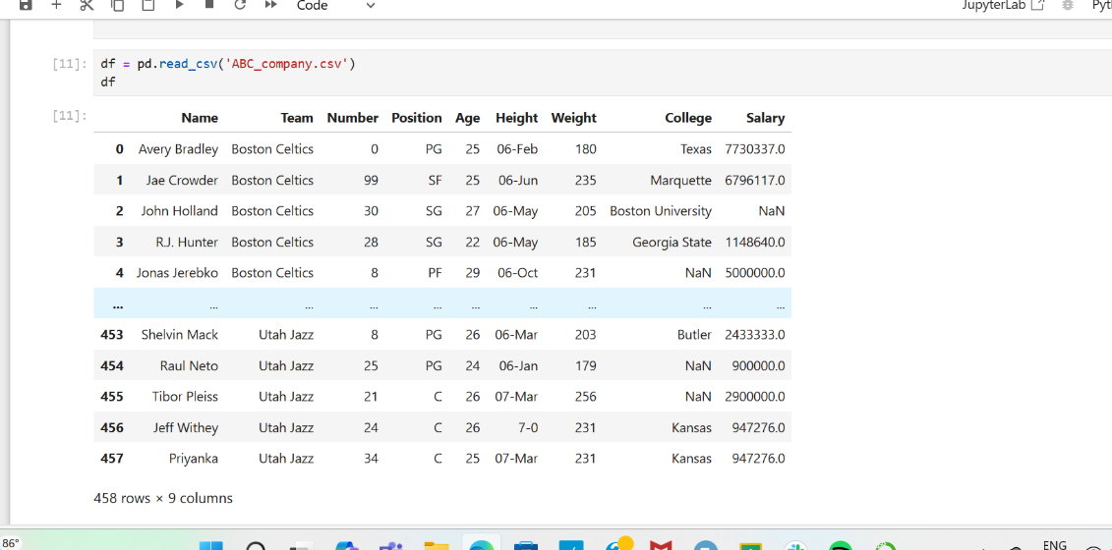

df = pd.read_csv('ABC_company.csv')

df

df['Height']=np.random.randint(150,181,df.shape[0])

print(df['Height'].describe())

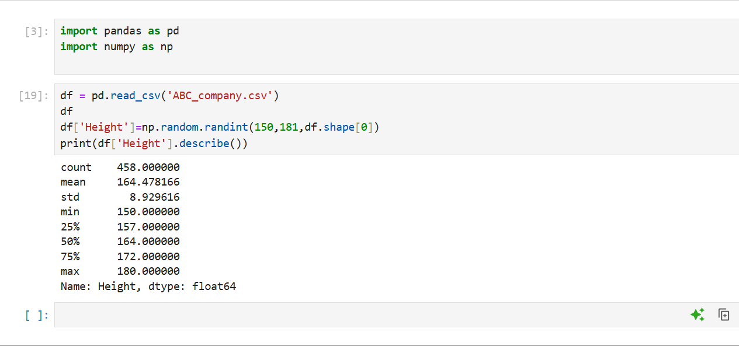

1.Determine the distribution of employees across each team and calculate the percentage split relative to the total number of employees

Team_dist= df['Team'].value_counts()

Team_percentage=(Team_dist/len(df))*100

print(Team_percentage)

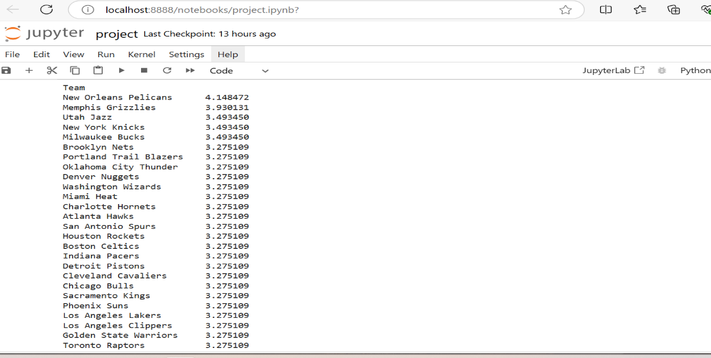

2.Segregate employees based on their positions within the company.

position = df.groupby('Position')['Name'].count()

print(position)

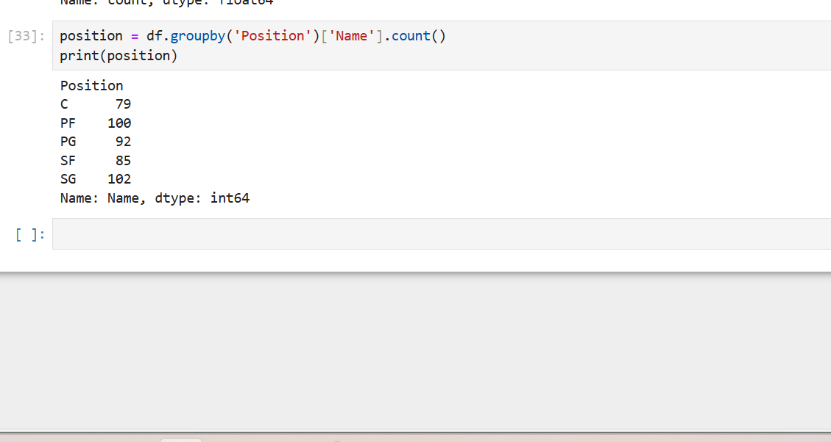

1. Identify the predominant age group among employees.

bins=[20,30,40,50,60]

age_groups=pd.cut(df['Age'],bins=bins)

pred_age=age_groups.value_counts().idxmax()

print(pred_age)

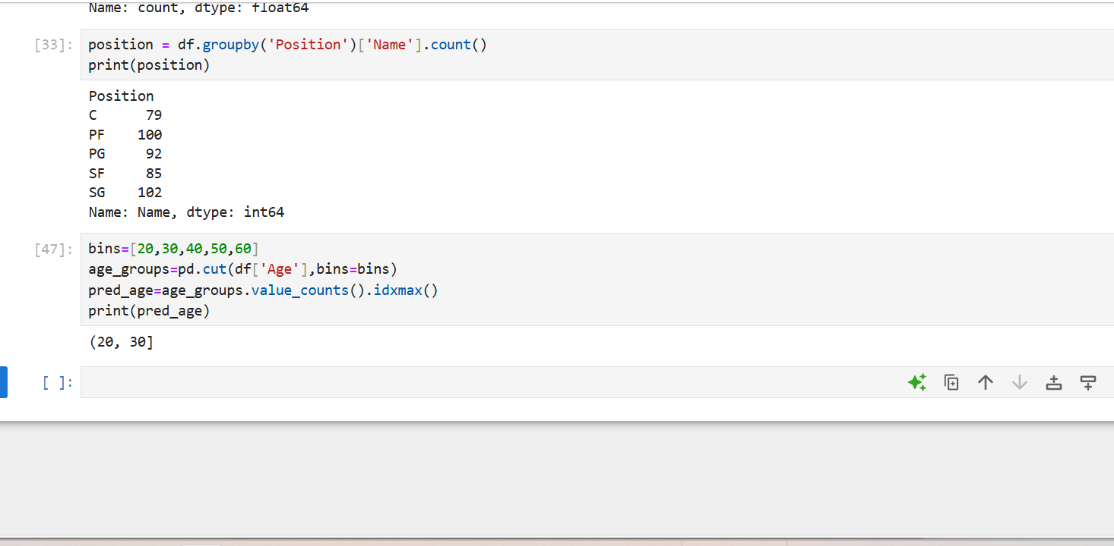

1. Discover which team and position have the highest salary expenditure.

high_salary_position=df.groupby(['Team','Position'])['Salary']

max_salary=high_salary_position.idxmax()

print(max_salary)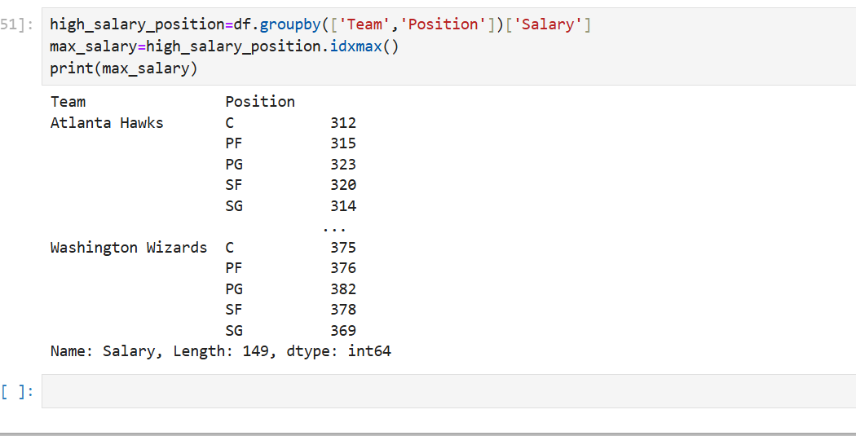

1. Investigate if there's any correlation between age and salary, and represent it visually.

import matplotlib.pyplot as plt

correlation=df['Age'].corr(df['Salary'])

print(f"Correlation between age and salary:{correlation}")

**type 1 visualization**

plt.scatter(df['Age'],df['Salary'],color='orange')

plt.xlabel('Age')

plt.ylabel('Salary')

plt.title("Correlation between Age and Salary")

plt.show()

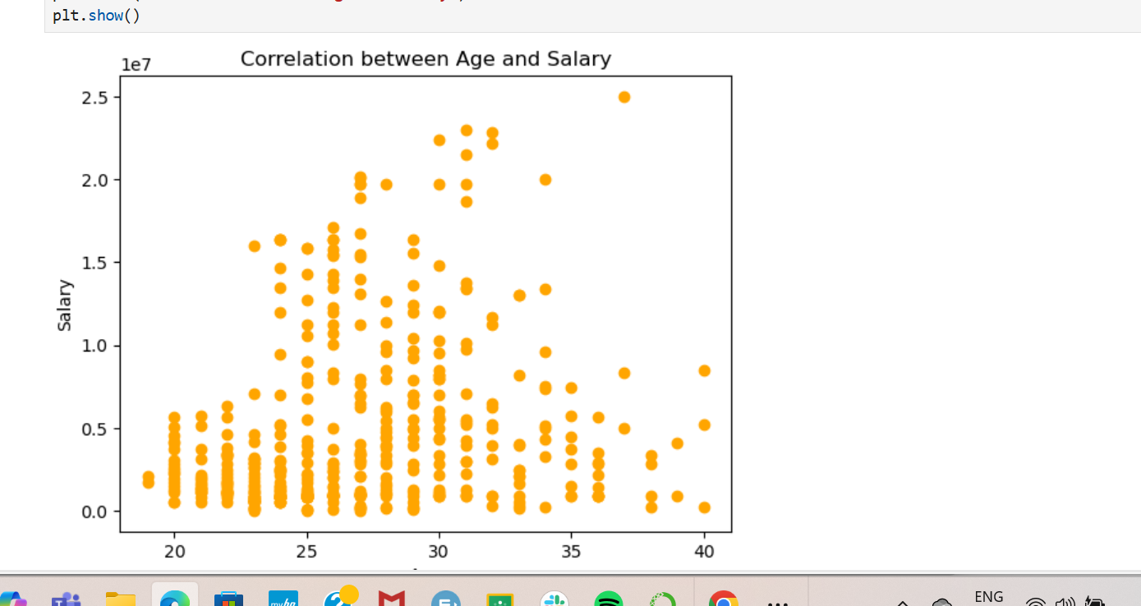

**type2**

plt.bar(df['Age'],df['Salary'],color='red')

plt.xlabel('Age')

plt.ylabel('Salary')

plt.title("Correlation between Age and Salary")

plt.show()

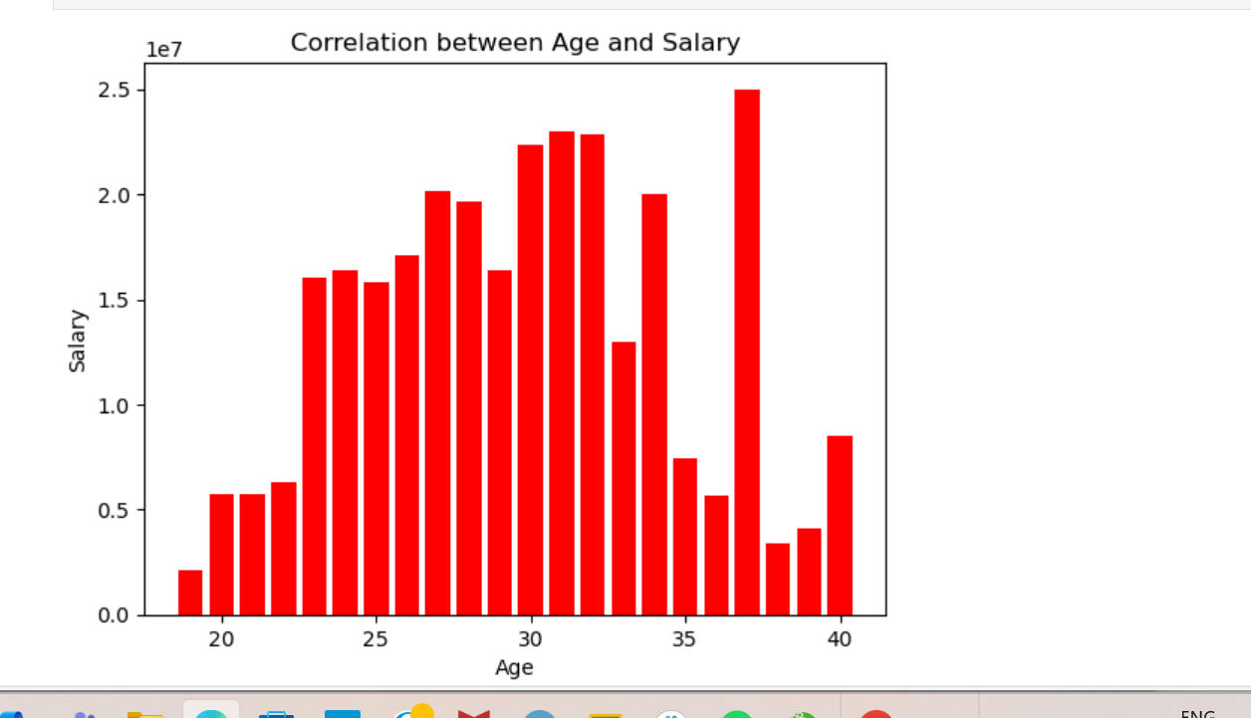

***GRAPHICAL REPRESENTATION For each of the five analysis tasks, create appropriate visualizations to present your findings effectively.***

**Visualization1:**

plt.figure(figsize=(5, 3))

Team_dist=df['Team'].value_counts()

Team_dist.plot(kind='bar',color='lightcoral')

plt.gca().set_facecolor('lightyellow')

plt.title("Employees Ditribution Across Teams",color='blue')

plt.xlabel('Teams',color='red')

plt.ylabel('Number of Employees',color='red')

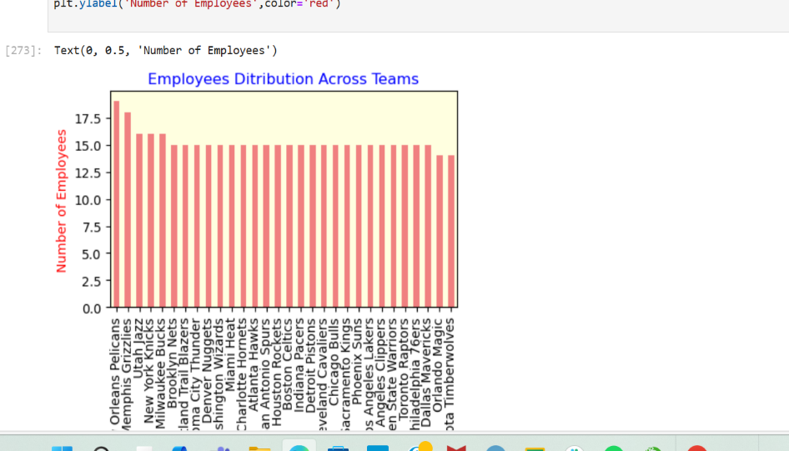

**Visualization 2**

Team_percentage=(Team_dist/len(df))*100

Team_percentage.plot(kind='pie',autopct='%1.1f%%', pctdistance=0.85,startangle=90,colors=['blue','green','pink'])

plt.title("Percentage of Employees in each team")

plt.ylabel('')

plt.show()

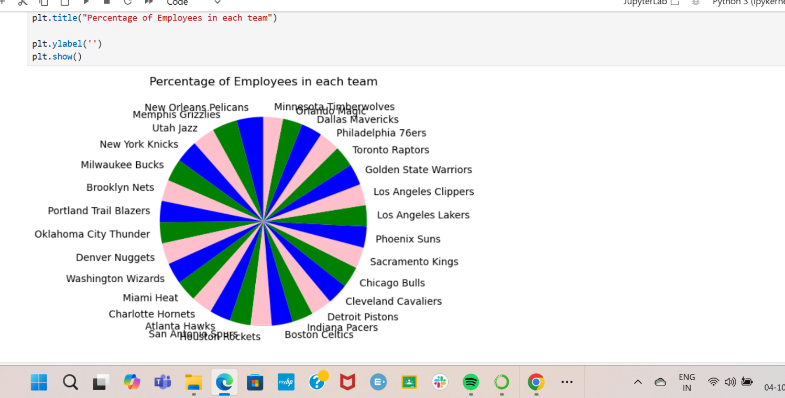

**visualization 3**

Team_percentage=(Team_dist/len(df))*100

Team_percentage.plot(kind='pie',autopct='%1.1f%%', pctdistance=0.90,colors=['skyblue','green','pink'])

centre_circle = plt.Circle((0, 0), 0.70, fc='white')

fig = plt.gcf()

fig.gca().add_artist(centre_circle)

plt.title("Percentage of Employees in each team",color='red')

plt.ylabel('')

plt.show()

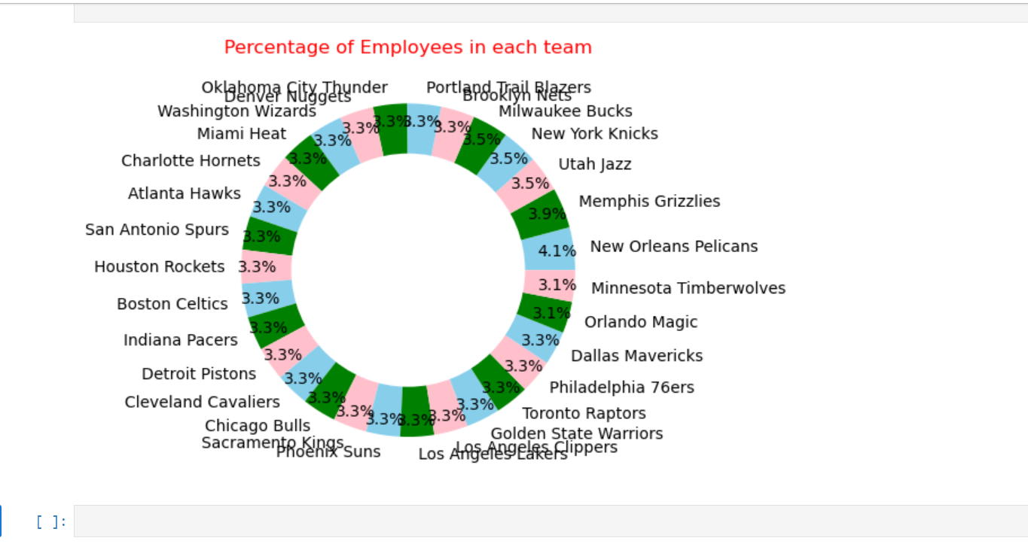

**visualization 4**

plt.figure(figsize=(5, 3))

position = df.groupby('Position')['Name'].count()

position. plot(kind='bar',stacked='True',color=['red','green','orange','coral'])

plt.gca().set_facecolor('lightyellow')

plt.title("Employees Job Position Details",color='blue')

plt.xlabel('Team')

plt.ylabel('No.of Employees')

plt.legend(title='position')

plt.show()

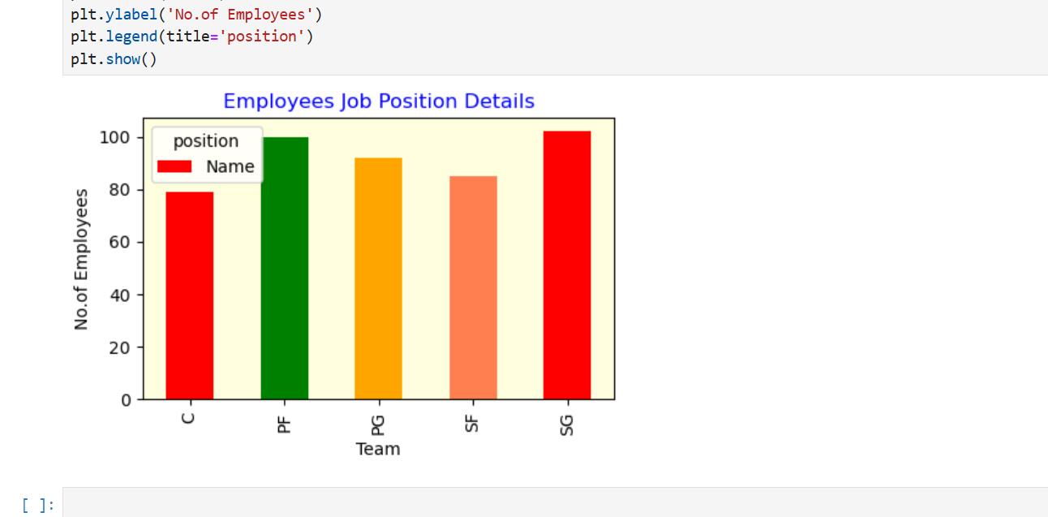

**visualization 5**

plt.figure(figsize=(6,3))

bins=[20,30,40,50,60]

plt.hist(df['Age'],bins=bins,color='coral',edgecolor='black')

plt.gca().set_facecolor('lightgreen')

plt.title("Predominant Age Group")

plt.xlabel("Age Groups")

plt.ylabel("No.of Employees")

plt.xticks(bins)

plt.show()

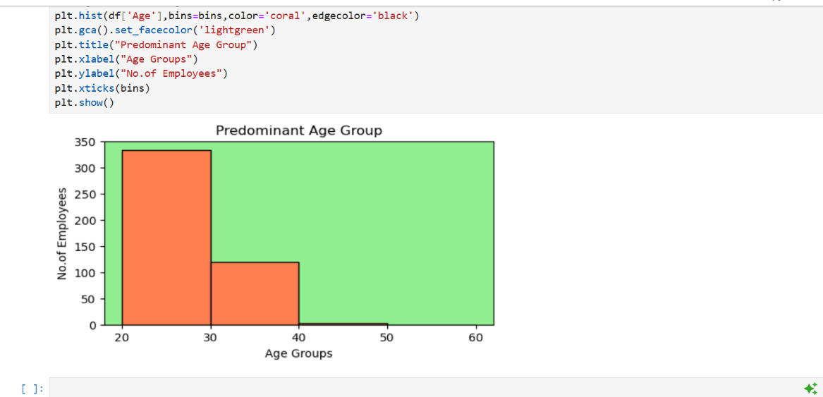

**visualization 6**

import seaborn as snc

high_salary_position=df.groupby(['Team','Position'])['Salary'].sum().unstack()

plt.figure(figsize=(10,6))

snc.heatmap(high_salary_position,cmap='viridis',annot=True,fmt='.0f')

plt.title("Salary Based report",color='coral')

plt.xlabel('Position',color='blue')

plt.ylabel('Team',color='blue')

plt.show()

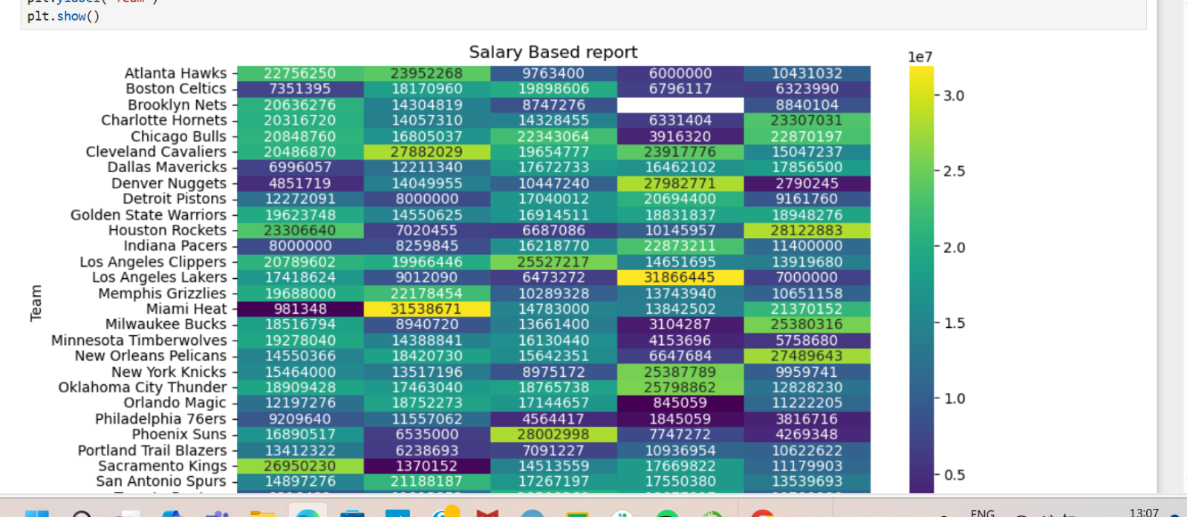

**visualization 7**

plt.scatter(df['Age'],df['Salary'],color='orange',edgecolor='red')

plt.gca().set_facecolor('lightyellow')

plt.xlabel('Age')

plt.ylabel('Salary')

plt.title("Age v/s Salary")

snc.regplot(x='Age',y='Salary' ,data=df,scatter=False,color='green')

plt.show()

